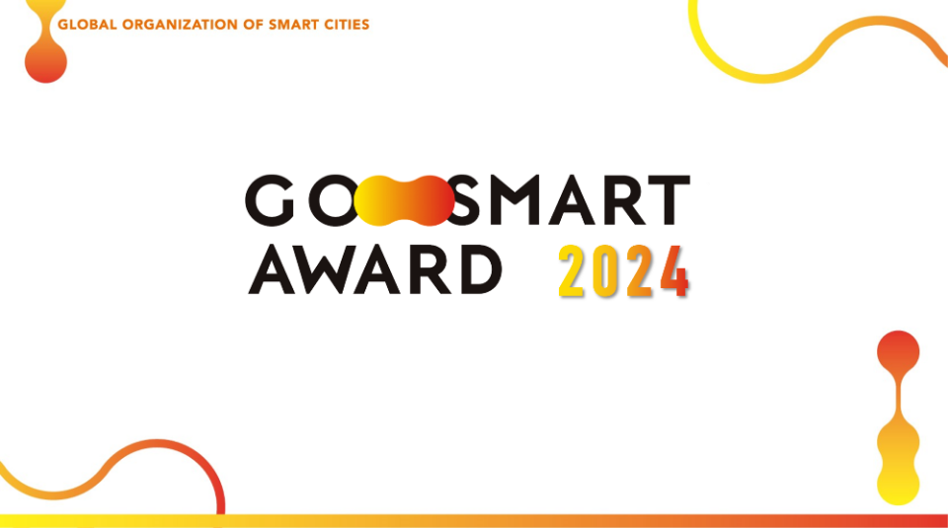

2024 GO SMART Award Application Form
Global Organization of Smart Cities welcome all the enthusiastic participants for submitting your excellent project. Please prepare the information and relevant documents.
Section I. Applicant's Contact Information *Upload* organization LOGO
Section II. Project Information *Upload* video link (1 min), and supporting images (max. 10MB)
全球智慧城市組織歡迎所有熱情的參與者提交您的優秀專案。請準備資訊和相關文件。
第一部分 申請人聯繫方式
*上傳*組織Logo
第二部分.專案資訊
*上傳*影片連結（1分鐘）和支援圖片（最大10MB）

- Section I. Applicant's Contact Information第一部分 申請人聯繫方式
Please fill out applicant contact information below. Organization LOGO should be uploaded.
請在下面填寫申請人聯繫資訊，應上傳組織Logo。
- Project Organizer專案主辦單位
- Contact Name聯繫人姓名
- Job Title職稱
- E-mail電子郵件
- Contact Number 聯繫電話(e.g. +886-2-2577-4249 #510)
- Organization Name機構名稱
- Sector of your organization您所在組織的部門
□Public公部門 □Private私人的 □NGO非政府組織
- City, Country (Organization based)城市，國家/地區
- Organization Website組織網站
- Organization Logo (file name as below)組織Logo（檔名如下）
yourorganization.logo （例如 gosmart.logo） 檔案大小限制為 10 MB 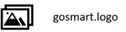

- Section II. Project Information第二部分.專案資訊
Please fill out your project information below. Please provide with us the in-depth information of your submission, so the juries can evaluate it more comprehensively.請在下面填寫您的專案資訊。請向我們提供您提交的詳細資訊，以便評審團可以更全面地評估。

- Project Name 專案名稱 (Max. 100 characters) （最多 100 個字元）
- Organization Profile組織簡介 (Max. 200 characters) （最多 200 個字元）
- Project Lead 專案負責人(Listed your Project Leader) （列出您的專案負責人）
Name, Job Title, Email Address, Contact Number 姓名、職位、電子郵件地址、聯繫電話
- Implementation Site 實施地點
Indicate to the cities where the project was or about to be implemented. 註明專案已實施或即將實施的城市。
- Abstract - Description of the project摘要 - 專案簡介 (Max. 1500 characters) （最多1500個字元）Please provide a description of the project, explaining the issues addressed by this solution and the expected outcomes. You may include the problem node(s), solution(s), scope of implementation, objectives, potential replicability. Please include any relevant background information.請提供專案說明，解釋該解決方案解決的問題以及預期結果。包括問題節點、解決方案、實施範圍、目標、潛在的可複製性。請提供任何相關的背景資訊。
- Cross-Domain characteristics of the project (Max. 1000 characters) 專案的跨域特徵（最多1000個字元）
- Potential impact of the project 專案的潛在影響(Max. 1000 characters)
Please describe how your project will create a positive impact for a particular issue or problem in your city or context. Are there any SDGs or specific impact areas that the project aims to address? 1. If your project has been implemented: To what extent was the intended impact of this project realized? Please share both quantitative and qualitative metrics which you are using to measure your project impact (e.g. adoption/usage as a % of total population, no. of citizens who benefit from your project, time or cost savings, etc.). 2. If your project has not been implemented or is in progress: a. What is your measurable project impact so far? b. How much progress have you made in implementing your project?
請描述您的專案將如何對您所在城市或環境中的特定問題產生之正面影響。該專案是否有任何旨在解決的永續發展目標或具體影響領域？1. 如果您的專案已經實施：該專案的預期影響在多大程度上實現了？請分享您用來衡量專案影響的定量和定性指標（例如，採用/使用佔總人口的百分比、從您的專案中受益的公民數量、節省的時間或成本等）。2. 如果您的專案尚未實施或正在進行中：a.到目前為止，您的可衡量專案影響是什麼？b.您在實施專案方面取得了多少進展？

- Functionality of the project 專案的功能 (Max. 1000 characters)
Please indicate the cities’ challenge from the cities perspective and how challenge is solved by your project. What is the problem being addressed by this project? How does the function of your solution improve things for the city compared to the existing approach and alternative methods to solve the problem? How has your solution/approach been implemented?
請從城市的角度說明城市面臨的挑戰，以及您的專案如何解決挑戰。該專案要解決的問題是什麼？與解決問題的現有方法和替代方法相比，您的解決方案的功能如何改善城市的情況？您的解決方案/方法是如何實施的？
- Innovative characteristics of the project (Max. 1000 characters) 專案創新特色（最多1000個字元）
How innovative/creative/unique is the idea? Is there a novel approach applied to solve the problem? If your project can be scaled by Technology readiness levels (TRL), please describe which level of your project.
此專案有哪些創新性/創意性/獨特性？在解決相關問題時，是否有使用新穎、獨特的方法？ 如果您的專案可以按技術成熟度 (TRL) 進行擴展，請描述您的專案處於哪個層級。
- Inclusiveness of the project (Max. 1000 characters)專案的包容性（最多 1000 個字元）
Smart City development is for the benefit and welfare of its citizen. The human centric approach with inclusiveness is indeed what we, GO SMART Award, value and recognize. We would like to see the project with features, like thinking of and looking after the interests of all kinds of citizens, especially economically/socially/healthily disadvantaged groups of people. Tell us about this project’s inclusiveness from initial planning stage to now or its end - how did (do) you include the participation for, of, with, and/or by most of the citizens- particular the interests of the disadvantaged in this project?
智慧城市的發展是為了公民的利益和福祉。 以人為本的包容性方法是GO SMART Award 所重視和認可的。 我們希望看到這個計畫具有特色，例如思考和照顧各類公民的利益，特別是經濟/社會/健康上的弱勢群體。 請參與者告訴我們這個計畫從最初的規劃階段到現在或結束，如何呈現包容性—你是如何將大多數公民的參與、和/或大多數公民的參與—特別是弱勢群體的利益納入這個項目的？
- Stakeholders/Partners involved 產業相關者/合作夥伴參與
Please list different stakeholders/partner with order and describe their contribution and prioritize involvement (%). (For example, A company (20%): provide hardware technique assistance. B company (20%): provide software technique assistance.) Is the submitter of this project the main initiator of this project/policy? If not, please describe the initiator of this project, and what its engagement in this project is? Please describe what is the method and the cooperation mode.
請按順序列出不同的產業相關者/合作夥伴，並描述他們的貢獻並優先考慮參與（%）。（例如A公司（20%）：提供硬體技術援助。B公司（20%）：提供軟體技術援助。）該專案的提交者是否是該專案/政策的主要發起者？ 如果不是，請描述該專案的發起者，以及其參與專案的情況是什麼？ 請介紹一下具體的方式和合作方式。
- Summary Video摘要影片 File size limit is 50 MB Allowable file types: Video
Please provide a one-minute project introduction video, which can be shot using a mobile phone. If spoken in English, no post-production is needed. If spoken in your native language, please add English subtitles to help international judges quickly understand the project's content.
請提供一分鐘的專案介紹影片，可以用手機拍攝。如果使用英語進行，則不需要後製影片。如果用您的母語，請添加英文字幕，以幫助國際評審快速理解專案內容。
檔案大小限制為 50 MB 允許的檔案類型：Video
(請提供檔案)
- Supporting Links支援連結
You may provide the link to the project website, news releases, youtube channel or any other supporting links.
您可以提供專案網站，新聞發佈，YouTube頻道或任何其他支援連結的連結。
- Supporting Material (file name as below) 補充資料（檔名如下）
You may upload a relevant document (PDF file) or image (only in JPG, JPEG, PNG, GIF) to support the application.您可以上傳相關文檔（PDF檔）或圖像（僅以JPG，JPEG，PNG，GIF格式）來支援該申請。
檔案大小限制為 10 MB 允許的檔案類型：文件、圖像
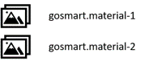
- How did you hear about us? 您是如何得知我們的？

□GO SMART Official □GO SMART Linkedin page

□GO SMART Twitter □Others
- Which media press or platform transferred you to our webpage? 哪家媒體或平台將您轉至我們的網頁？
- Your comments and suggestions are welcome! 歡迎您的意見和建議！
If there is any question in filling the application, please don’t hesitate to contact us via email: gosmartcities@citiesgosmart.org
如果填寫申請表時有任何疑問，請隨時透過電子郵件與我們聯繫：gosmartcities@citiesgosmart.org

